Experiment 5
Diodes and DC Power Supplies

PART 1: DIODE CHARACTERISTICS
The aim of this part of the experiment is to verify the I-V characteristics of diodes (normal and Zener diodes).
DA
P
Q
R
+12 V
–12 V
Fig. 1 Difference Amplifier

Difference Amplifier (DA)
A difference amplifier has two inputs (P and Q) and one output (R) as shown in Fig. 1. It is possible to design a DA such that its output voltage V_{R} is equal to the difference of the two input voltages V_{Q} and V_{P}. That is, V_{R} =V_{Q} - V_{P}.
The difference amplifier circuit is already made on a printed circuit board (PCB) with P and Q as its inputs and R as its output.

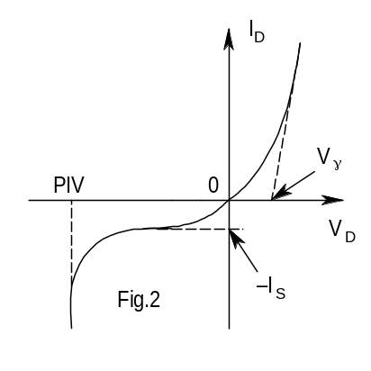1.1 Diode
The diode current I_{D} as a function of the voltage V_{D} across it (with its polarity given by that of the p-region with respect to the n-region) is given by: I_{D} = I_{S}[exp{V_{D}/(nV_{T})} − 1], where I_{S} is called the reverse saturation current of the diode (typically ranging from pA to μA), V_{T} (= kT/q) is the thermal voltage (= 26 mV at 300 K), and n is called the non-ideality factor (typically ranging between 1 and 2). A typical diode characteristic is shown in Fig.2.
When a silicon diode is forward biased (i.e., positive V_{D}), very little diode current I_{D} flows till V_{D} reaches about 0.5 V. However, beyond this point (known as the knee voltage (V_{γ}) of the diode, as shown in Fig.2), with further increase in V_{D}, I_{D} starts to increase rapidly with V_{D}. When the diode is reverse-biased (i.e., negative V_{D}), the diode current reverses its direction and maintains a nearly constant value of I_{S}. The magnitude of the reverse-bias across the diode should not exceed its peak inverse voltage (PIV), as shown in Fig.2, since it would result in a destructive breakdown of the diode.

Experiment
A. Wire the circuit of Fig.3. Connect the inputs to the DA as indicated. Be sure to connect the +12 V, −12 V, and GND connections also to the PCB. Note that the DA measures the diode current in mA. Hence, 1 mA of current will give 1 Volt at the V_{A} output.
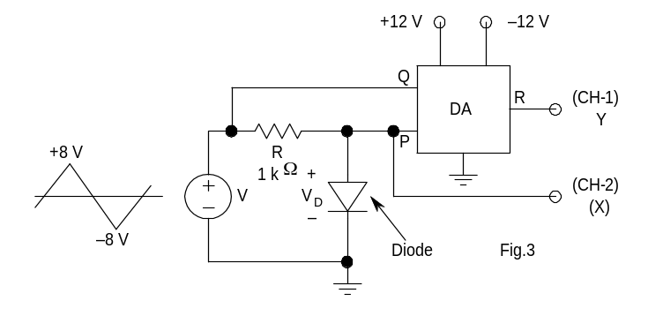
B. Apply an 8 V peak triangular wave (having a frequency f of 200 Hz) as the input to the circuit. Connect the diode voltage V_{D} to CH1 and the DA output V_{A} to CH2. Make sure that you are getting waveforms on these channels.
V_{A}
V_{D}
CH2
CH1
C. Put the DSO in the XY mode and adjust the beam such that the origin is at the centre of the DSO display.
D. See the XY plot on the DSO, and verify that you are getting the correct diode characteristic.
E. Estimate the knee voltage V_{γ} of the given diode. Choose CH-2 voltage setting as 0.5 V/div or 0.2 V/div for this purpose.
F. Sketch the diode characteristic and note down the salient points. (You will see that a practical diode is quite different from an ideal one).
G. Estimate the diode forward resistance by measuring the slope of the characteristic in the conducting region (choose a nearly linear region). For this purpose, measure accurately the diode voltages and currents at two points in the displayed characteristic.

1.2 Zener Diode
Zener diodes are special diodes with lower reverse breakdown voltages. Zener diodes are used as reference voltage sources in regulated DC power supplies.

Experiment
Wire the circuit of Fig.3 with the given Zener diode instead of the diode used in Sec.1.1. Repeat the steps (A) to (G) of Section 1.1 and obtain the characteristics of the given Zener diode. (Note that the Zener has very similar forward characteristic in the 1st quadrant). In step (E) measure both the Zener breakdown voltage (V_{Z}) and the forward knee voltage (V_{γ}). Similarly, in step (G) measure the resistances in both the forward and Zener regions.
CAUTION: The circuit under test can provide enough power to heat some components and burn them, or blow the fuse. So be extremely careful and doubly ensure that your wiring is correct. Also ensure that all contacts are firm and none loose. At no point of the experiment, the outputs of the transformer, or the rectifier should be short-circuited.

PART 2: DC Power Supply
CAUTION: The circuit under test can provide enough power to heat some components and burn them, or blow the fuse. So be extremely careful and doubly ensure that your wiring is correct. Also ensure that all contacts are firm and none loose. At no point of the experiment, the outputs of the transformer, or the rectifier should be short-circuited.
The regulated DC power supply is the principal source in almost all electronic equipment. A commercial DC power supply will consist of a rectifier circuit, a filter circuit to reduce the AC components from the rectifier output, and an electronic regulator to provide a DC output voltage, which remains almost constant irrespective of the fluctuations in the mains supply and load current. The aim of this experiment is to familiarize you with various parts of un-regulated DC power supplies and their characteristics.

Step-Down Transformer
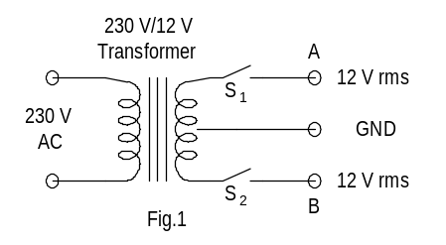
Note that the step-down transformer shown in Fig.4 is fitted on the panel of your lab benches. This is a 12 V-0-12 V (i.e., a center-tapped) transformer. Because of this configuration, the voltages at the points A and B are exactly out of phase with respect to GND. These outputs are brought out to the sockets on the panel through two switches (S₁ and S₂). Turn these switches off when this part of the power supply is not being used.
Fig. 4

2.1 Half- and Full-Wave Rectifiers (without Capacitive Filtering)
The aim of this section is to study the characteristics of half-wave and full-wave rectifiers. Use only the given high-wattage 100 Ω resistor as the load.
Experiment
- HALF-WAVE RECTIFIER
Wire the half-wave rectifier circuit of Fig.5. Observe and sketch the input and the output waveforms.
- FULL-WAVE RECTIFIER
Wire the full-wave rectifier circuit of Fig.6. Observe and sketch the input and the output waveforms.

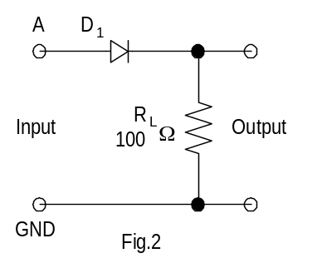
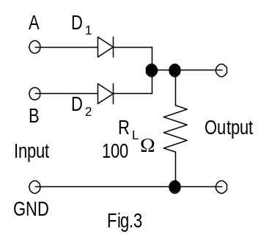
Fig. 5
Fig. 6

2.2 Rectifiers (with Capacitive Filtering)
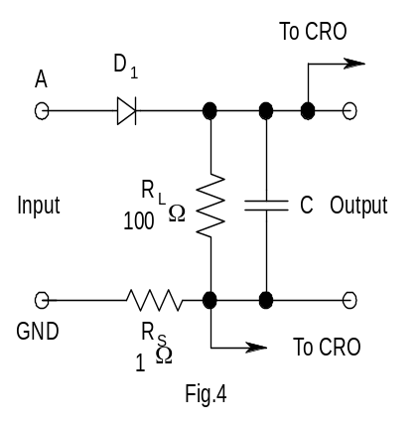
In this section, you will study the effect of capacitive filters on ripple voltage and peak diode current. The 1Ω resistor in the following circuits is used to observe the diode current waveforms. Use one channel of the DSO to observe the output voltage and the other channel to observe the diode current simultaneously.
Fig.7

Experiment

A. HALF-WAVE RECTIFIER
(i) Wire the half-wave rectifier circuit of Fig.7. Use C=330 μF.
(ii) Observe and sketch the output voltage and the diode current waveforms.
(iii) Measure the peak-to-peak ripple voltage and the peak value of the diode current.

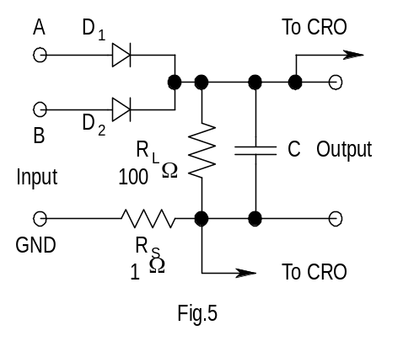
B. FULL-WAVE RECTIFIER
Fig. 8
(i) Wire the full-wave rectifier circuit of Fig.8.
(ii) Repeat steps (ii) and (iii) of Section 2.2 (A) for C=100 μF, 330μF and 1000 μF.

Compare the peak-to-peak ripple voltage and the peak value of the diode current for half-wave and full-wave rectifiers with C=330μF. Which one gives lower ripple voltage?
Justify your answer.

